Johnathan Davis
Executive Director, Baltimore Crisis Response, Inc.
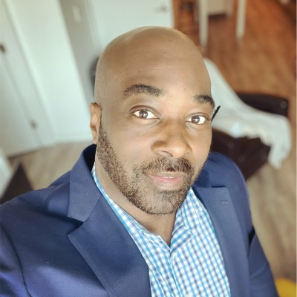
Johnathan Davis is a native of Atlanta, GA. Davis is licensed by the State of Georgia as a Clinical Professional Counselor and holds a national counseling certification. Davis has always demonstrated a passion to work with vulnerable populations through his service with local faith assemblies, community organizations, and volunteer efforts. With approximately 20 years of experience working in social service and state level government, he contributes in varying and escalating leadership capacities to national, state, and community human service initiatives including leadership and oversight, policy development and regulation, program evaluation and consultation, and constituent and stakeholder engagement.

Before accepting the role of Chief Executive Officer with Baltimore Crisis Response, Inc., Davis was a Deputy Administrator with the Department of Human Services in Washington, D.C. and worked as the Executive Director for Covenant Community, Inc., a nonprofit organization in Atlanta, GA.

Additionally, Davis was appointed to Mayor Keisha Lance Bottoms’ Use of Force Advisory Council to provide meaningful recommendations around police reform. In this role, he led subcommittee work around transparency and reporting. Davis also served as the District 3 Board of Commissioners Appointee for the Fulton County Continuum of Care (Vice Chair and Governance Committee Chair) and as a Board Member for Georgia Equality, the Equality Foundation of Georgia, the Georgia Association of Recovery Residences (Strategy Chair), Back to Basics Kids Foundation (Program Development and Evaluation Chair), and a number of other community steering committees and advisory councils.

As a family driven man, Davis’s primary goal is to make this world a better place for his niece, nephews, and others.

Brandon M. Scott
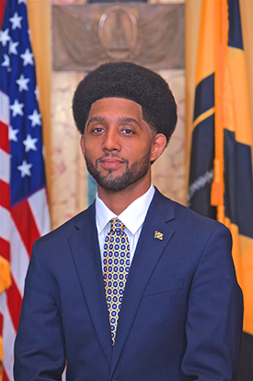
Mayor, Baltimore City
Brandon M. Scott serves as the 52nd Mayor of Baltimore City. One of the youngest people ever elected, he has been working in the public sector in Baltimore since he was 27 years old. Beginning in 2019 while acting as City Council President, Mayor Scott focused on building safer, stronger communities, cleaning up city government, investing in Baltimore’s young people, and centering equity. As a lifelong Baltimore resident, he works daily to end gun violence, restore the public’s trust in government, and change Baltimore for the better.
Previously serving as a member of the Young Elected Officials Network, the Secretary of Housing and Urban Development for YEO’s America’s Cabinet, and Chair of the National League of Cities' Large Cities Council, Mayor Scott is a rising star in politics. Since 2016 he has passed legislation that is monumental, taking a holistic, all-hands-on-deck approach to reducing violence in Baltimore and recognizing this violence as fundamentally a public health issue.
Mayor Scott has also led legislative initiatives that created extensive crime data sharing and online reporting of crimes by the Baltimore Police Department. Mayor Scott introduced and passed legislation creating an open data policy in Baltimore. He also created an equity assessment program law requiring transparency from city agencies related to operating budgets, capital budgets, and proposed legislation.
Mayor Scott is a community leader and public servant, who continues to work to make Baltimore a better place.

Johnny Olszewski, Jr.
Baltimore County Executive
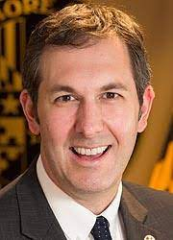
John “Johnny O” Olszewski, Jr. is a lifelong Baltimore County resident whose work earned him a reputation as a “rising star” of Maryland politics. Elected to the Maryland House of Delegates in 2006 and re-elected in 2010, Olszewski served as the Chairman of the Baltimore County House Delegation and was the youngest person ever elected to that position. He helped lead unprecedented progress for the County in areas such as economic development and school board reform. As a staunch advocate of working families, Olszewski led the charge on providing earned sick leave and raising the minimum wage. He also made a critical vote to secure marriage equality in the State of Maryland.
As a state delegate, Olszewski served on the House Economic Matters Committee and chaired the subcommittee on Banking, Economic Development, Science and Technology. He has also served on Maryland’s P-20 Leadership Council and the Maryland Business Climate Workgroup. Olszewski is a former student member of the Baltimore County Board of Education, a 2010 graduate of Leadership Baltimore County, and was recently recognized as one of the Daily Record’s “Top 40 under 40” in 2019. He is an active philanthropic and economic development leader who has served as a member of the Business Network for Offshore Wind Board, the Community College of Baltimore County’s Dundalk Foundation Board, and the Goucher College Board of Trustees.
Before his election to Baltimore County Executive, Olszewski worked in the private sector at SAS Institute where he partnered with governments to help prevent fraud, enhance public safety, improve program performance, and enable greater transparency. As County Executive, Olszewski has focused on improving education and making government more transparent and accountable. Since taking office, he has provided record funding for Baltimore County Public Schools, made the County budget process more transparent, and created an Office for Ethics and Accountability.

Quinita Garrett
Director of Call Center and System Coordination, Baltimore Crisis Response, Inc.
A Licensed Clinical Professional Counselor, Quinitia Garrett has extensive experience providing suicide and crisis intervention for both adults and children. Garrett has worked with Baltimore Crisis Response, Inc. since 2014. Previously a Suicide Prevention Case Manager, she currently serves as the Director of Call Center and System Coordination, overseeing the day-to-day operations of the 988 Helpline.

Garrett’s role also ensures Baltimore Crisis Response, Inc. maintains acceptable levels of quality and quantity in the delivery of services including compliance with National Suicide Prevention Lifeline standards. She also ensures compliance to maintain ASS certifications and CARF standards for call center activities.

Nicki McCann
Vice President, Provider/Payer Transformation, The Johns Hopkins Health System

Nicki McCann has served as Vice President of Provider/Payer Transformation for the Johns Hopkins Health System since 2019. In this role, she works alongside providers and community organizations to develop strategies and programs that improve patient-centered care in alignment with the Maryland Total Cost of Care Model. McCann also works with policy makers and payers to explore value-based models of care and pursues policy changes with elected and appointed officials to improve the delivery of quality care.

McCann has many years of experience in program development and management, policy analysis, and leadership advisory work. She came to Johns Hopkins in 2010 as Director of Health Policy for Government Affairs. In this role, she advised leadership on health policy issues and advocated to advance industry priorities under Maryland’s rate-setting system. In 2018, McCann was appointed Chief of Staff for the Johns Hopkins Hospital.

She is chair of the Maryland Medicaid Advisory Committee, a fellow in the Carol Emmott Fellowship program for women leaders, and chair of the Greater Baltimore Regional Integrated Crisis System Partnership Council. McCann earned her juris doctorate from the University of Baltimore School of Law.

Crista Taylor
President & CEO, Behavioral Health System Baltimore
Crista Taylor is the President and CEO of Behavioral Health System Baltimore. A licensed clinical social worker, Taylor is recognized as a leader in behavioral health. She has experience working with policymakers, nonprofit organizations, and elected officials on innovative approaches to improving the behavioral health of Marylanders.
Taylor has more than 20 years of experience in the behavioral health field where she has overseen the implementation of a range of programs that improved the quality of care delivered in the Public Behavioral Health System. Since 2005, she has developed innovative and cost-effective behavioral health approaches to service delivery at the Behavioral Health System Baltimore (formerly, Baltimore Mental Health Systems). With partner organizations in the community, Taylor led the development of a Forensic Assertive Community Treatment team, a mental health docket in the Circuit Court of Baltimore, and served on the executive team that led to the creation of the Behavioral Health System Baltimore. Previously, she was the Program Director for the Community Institute of Behavioral Services Mobile Treatment Program at Bon Secours Baltimore Health System, participated in Maryland’s initiative for implementing Assertive Community Treatment, and served as a psychiatric therapist at Johns Hopkins Hospital providing treatment in various outpatient settings and performing street outreach to people experiencing homelessness.

Adrienne Breidenstine
Vice President of Policy and Communications, Behavioral Health System Baltimore
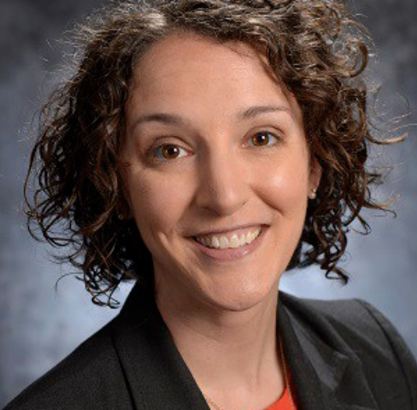
Adrienne Breidenstine is Vice President of Policy and Communications with Behavioral Health System Baltimore (BHSB). Breidenstine received a master’s degree in social work with a concentration in social action and community development from the University of Maryland, Baltimore. She now directs the development of communications, policy, and advocacy activities for BHSB, coordinates BHSB’s policy priorities with non-profit and governmental partners, implements media, public education, and advocacy campaigns to create positive behavior and policy change, and oversees the implementation of the Greater Baltimore Regional Integrated Crisis System (GBRICS) partnership.
Breidenstine has over 15 years of experience with health and housing policy helping shape homelessness and health care policy reforms at both the federal and local level. Prior to joining BHSB, she served as the Executive Director of the Journey Home for the Baltimore City Mayor’s Office of Human Services where she led the implementation of the Journey Home, Baltimore’s plan to end homelessness. In this role she established the first-ever performance management approach to track and evaluate progress and launched the Mayor’s 2015 Veteran Homelessness Challenge, a community collaborative that permanently housed over six hundred veterans.

