PRESS CONFERENCE: Baltimore Leaders Launch CALL 988 Mental Health Emergency Helpline

Wednesday, July 27, 2022 | 1 p.m.
5124 Greenwich Ave., Baltimore, MD 21229 (988 call center location)

Program Speakers:

Emcee: Adrienne Breidenstine, Vice President, Policy and Communications, Behavioral Health System Baltimore

- Johnathan Davis, LPC
Executive Director, Baltimore Crisis Response, Inc.

- Brandon M. Scott
Mayor, Baltimore City

- Johnny Olszewski, Jr.
Baltimore County Executive

- Quinita Garrett
Director of Call Center and System Coordination, Baltimore Crisis Response, Inc.

- Nicki McCann
Vice President, Provider/Payer Transformation, The Johns Hopkins Health System

- Crista Taylor
President & CEO, Behavioral Health System Baltimore

The press conference will take place Monday, July 27, at 1 p.m. at 5124 Greenwich Ave., Baltimore, MD 21229. For those who cannot attend in person, the event will be live streamed on Behavioral Health System Baltimore’s Facebook page: https://www.facebook.com/bhsbaltimore

FOR IMMEDIATE RELEASE Contact: Adrienne Breidenstine
July 27, 2022 443-447-3357
Baltimore-area leaders launch CALL 988 helpline to address the growing need for emergency mental health support and promote community emotional well-being
The 988 line provides free and confidential emergency emotional support 24 hours a day, 7 days a week
BALTIMORE – Baltimore-area leaders today announced the launch of CALL 988, a 24/7 comprehensive emergency mental health helpline that is part of the new national 988 network.
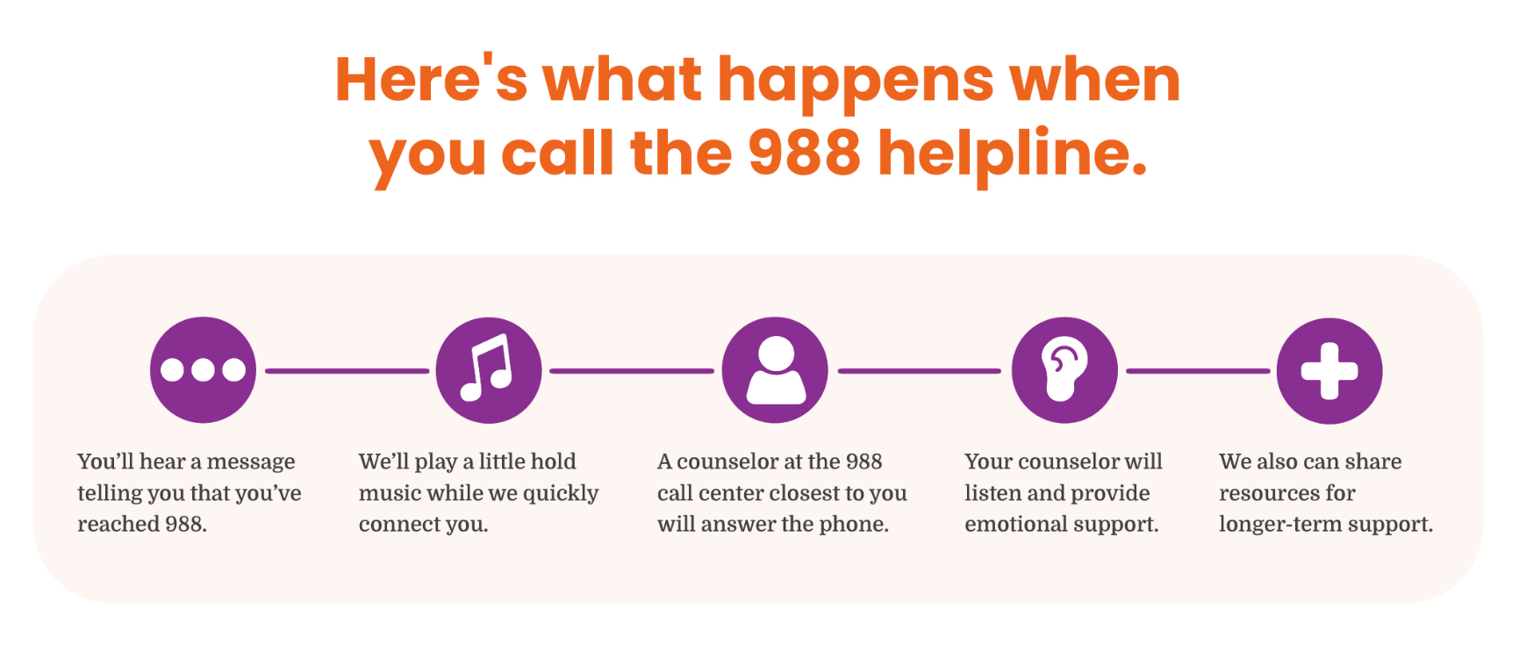
The launch of CALL 988 is the culmination of three years of planning to ensure callers across Maryland will be immediately connected to local call centers providing free, safe, supportive, confidential and professional care. CALL 988 aims to prevent suicide and provide quality emergency mental health care for all Central Marylanders in need.
“988 represents a transformational change in how we provide access to care for individuals and their families experiencing suicidal, mental health and substance use crises,” said Crista Taylor, president and CEO of Behavioral Health System Baltimore. “Having a simple, easy-to-remember number is a long-awaited change that our communities have been hoping for.”
Even before the COVID-19 pandemic, suicide and overdose rates had risen to historically high levels, and incidents of mental health challenges among Americans were increasing. Suicide is now the second leading cause of death in young people in the U.S., and the 10th leading cause overall. The 988 helpline was put in place to help address these issues and better connect people to compassionate, humane behavioral health care.
“While 911 is intended for police, fire or rescue emergencies, 988 is designed to address urgent mental and behavioral health needs,” said Baltimore City Mayor Brandon M. Scott. “In line with our commitment to develop alternative response strategies, 988 will reduce the involvement of police when responding to people in distress and limit our overreliance on emergency departments. Governments across the country are realizing that we do not need to and should not be providing a police response to calls that are better handled by trained professionals.”
“We want the community to know that we’re here to help,” said Johnathan Davis, executive director of Baltimore Crisis Response, Inc., one of three call center providers that staff the Baltimore regional 988 line. “People call 988 to talk about a range of things, like suicidal thoughts, relationships, economic worries, anxiety, sexual identity, drinking and substance use, feeling depressed, mental and physical illness, loneliness, trauma, and more. Our job is to connect them to the help they need.”
###
Quotes from Partners
Sen. Chris Van Hollen
“Far too many Americans experiencing mental health crises have nowhere to turn for help,” said Senator Chris Van Hollen. “Now, folks struggling with suicidal thoughts, addiction or a mental health crisis have a new way to access the help they need. 988 is going to save lives and strengthen public safety. I was proud to fight to fund and implement this program at the federal level, and I’m glad to see this critical helpline in action in Baltimore.”
Commissioner Dennis Frazier, Carroll County, District 3
“Mental health is a critical issue in all communities, and launching the national 988 helpline is a potential lifesaver for Carroll County residents, strengthening their connection to life-saving services and providing an important tool that everyone will know in any location,” said Carroll County Commissioner Dennis Frazier, District 3. “The easy-to-remember code will link anyone experiencing a crisis and needing assistance or someone with concerns about a loved one with quality help and support, allowing easier and faster access to our local community services.”
Dr. Mariana Izraelson, executive director, Grassroots Crisis Intervention Center, Inc
“We are proud to be a part of this experienced team of providers supporting the 988 helpline,” said Dr. Mariana Izraelson, executive director of Grassroots Crisis Intervention Center, Inc. “Together we make sure that individuals in the greater Baltimore area receive timely, qualified emotional support when they need it.”
Michelle Grigsby-Hackett, CEO, Affiliated Santé Group
“Once 988 is fully implemented, we anticipate seeing up to three times higher call volume,” said Michelle Grigsby-Hackett, CEO of the Affiliated Santé Group. “We’re looking forward to helping more residents access the emotional support they need, and we work closely with our partner call centers to make sure we’re able to provide consistent, quality care.”

